Inter widget communication

Navigate from one widget to another widget with passing data.

**Reference:**

<https://community.backbase.com/documentation/Retail-Banking/latest/how-to-communicate-between-widgets>

**Steps**:

1. Created below two widgets:-

Use following command to create widget from root of project

npm **run** ng -- generate widget --name=bb-account-selector-widget

npm **run** ng -- generate widget --name=bb-transaction-list-widget

* bb-account-selector-widget
  + which contain list of bank account
* bb-transaction-list-widget
  + Display transaction for selected bank account.

1. @Output – for sending data and receiving data through activated Router.

* bb-account-selector-widget :-

bb-account-selector-widget.component.ts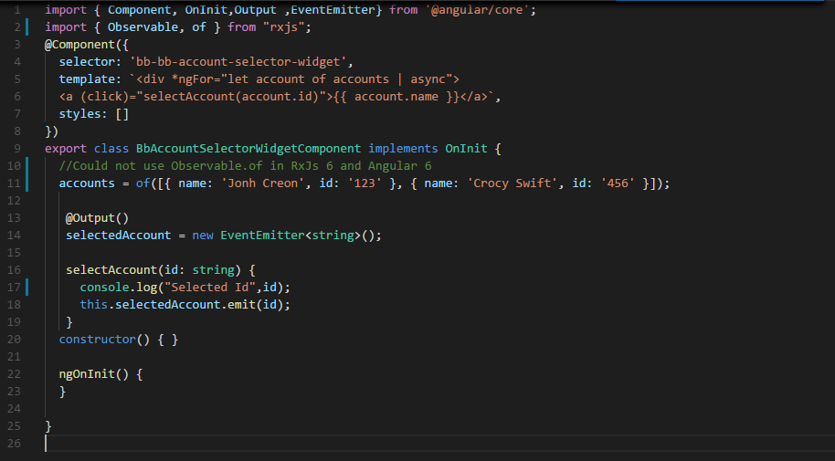

* bb-transaction-list-widget :-

For response handling we have use **filter**. i.e if selectedAccount is emitted then filter will handle the response.

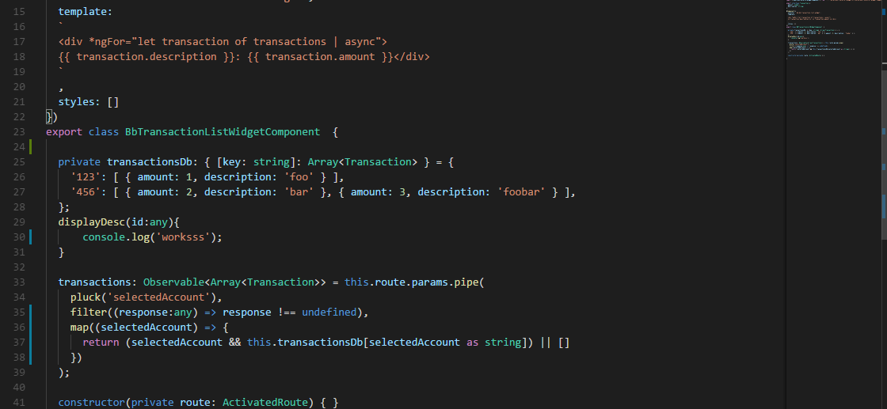

1. Navigation Output Handler :

* model.xml



1. Configuring flows :

* app/app.module.ts :-

There is no need to add declaration or mapping of data that is passes from one widget to another because we are using same name mapping in targeting widget i.e “selectedAccount”.

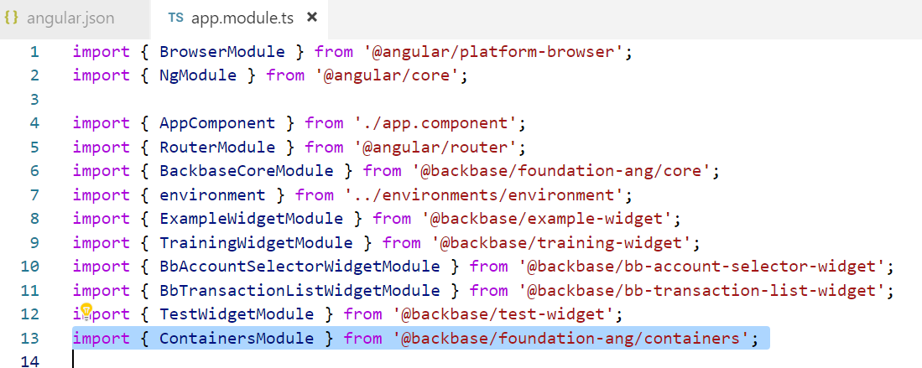

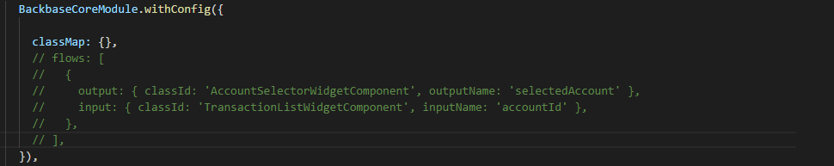

1. Add configuration in Pagemodel for running the app in standalone project

* dev-mocks.js :-

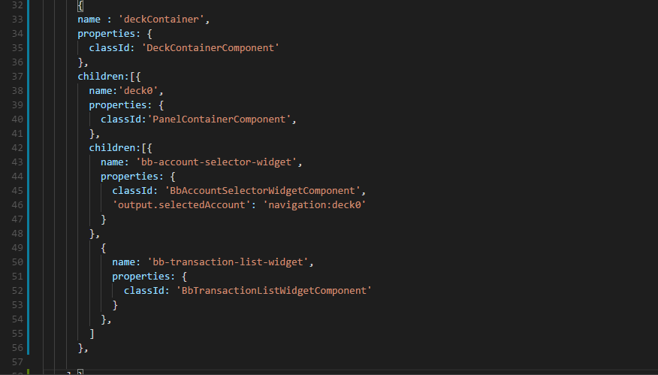

1. Packaging and Importing widget

* bb-package project
* bb-import package.zip

1. Rendering widget on Deck Container

Hierarchy should like in screen-shot:-

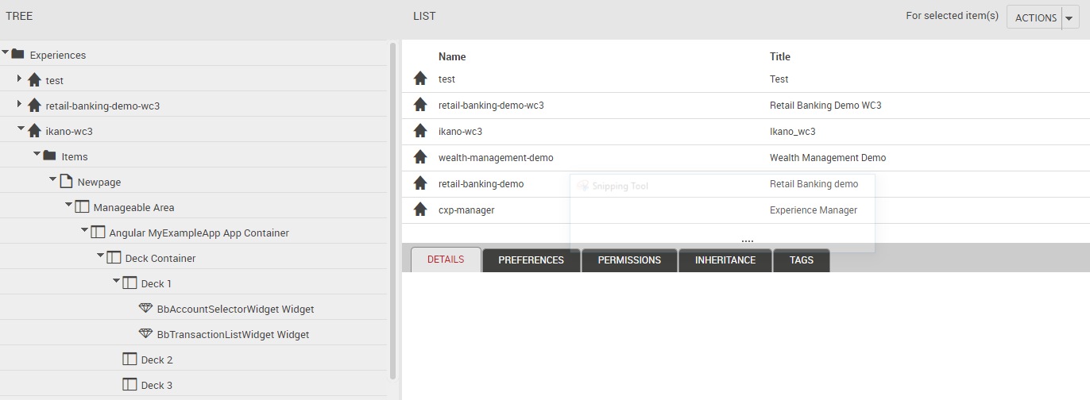

1. Explore Configuration:-

Copy name of deck container and add it to output.selectedAccount property of account selector widget to configure the action to take. Configuration name after navigation handler is the instance name of the widget that you want to navigate to.:-

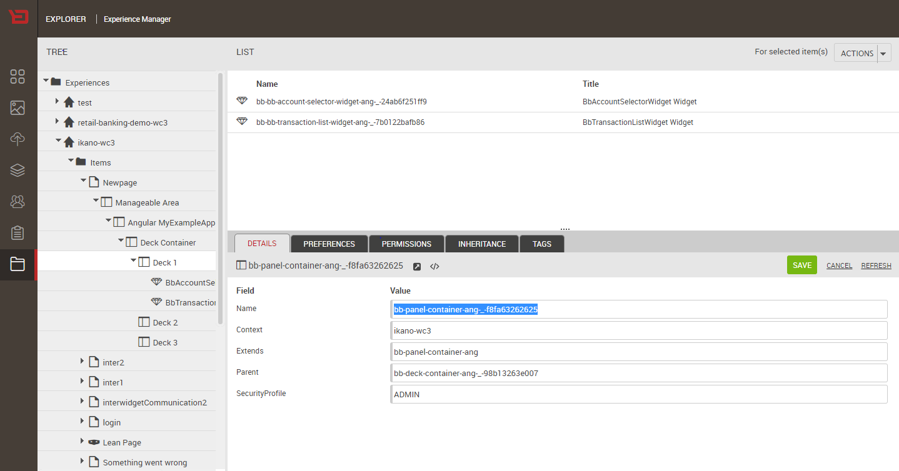

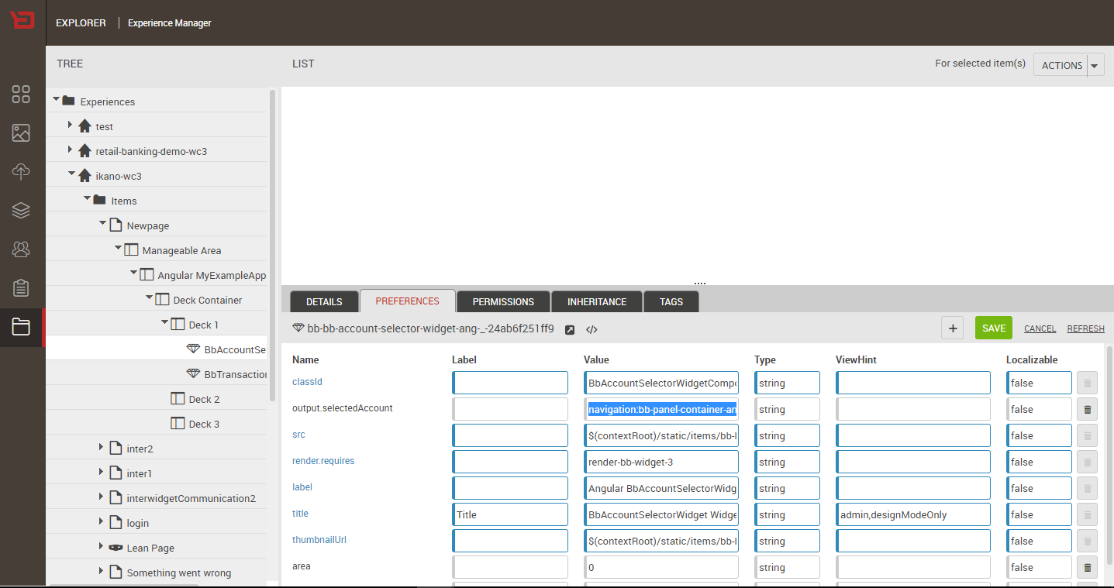

1. Output

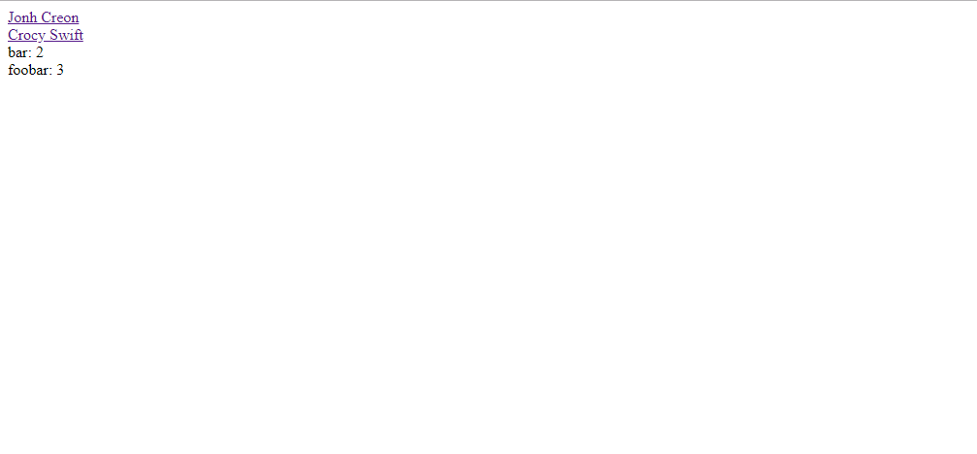

Understanding:-

* Following error occurs because of lean page version that we have used in CXS. This error will not cause any effect on our output.

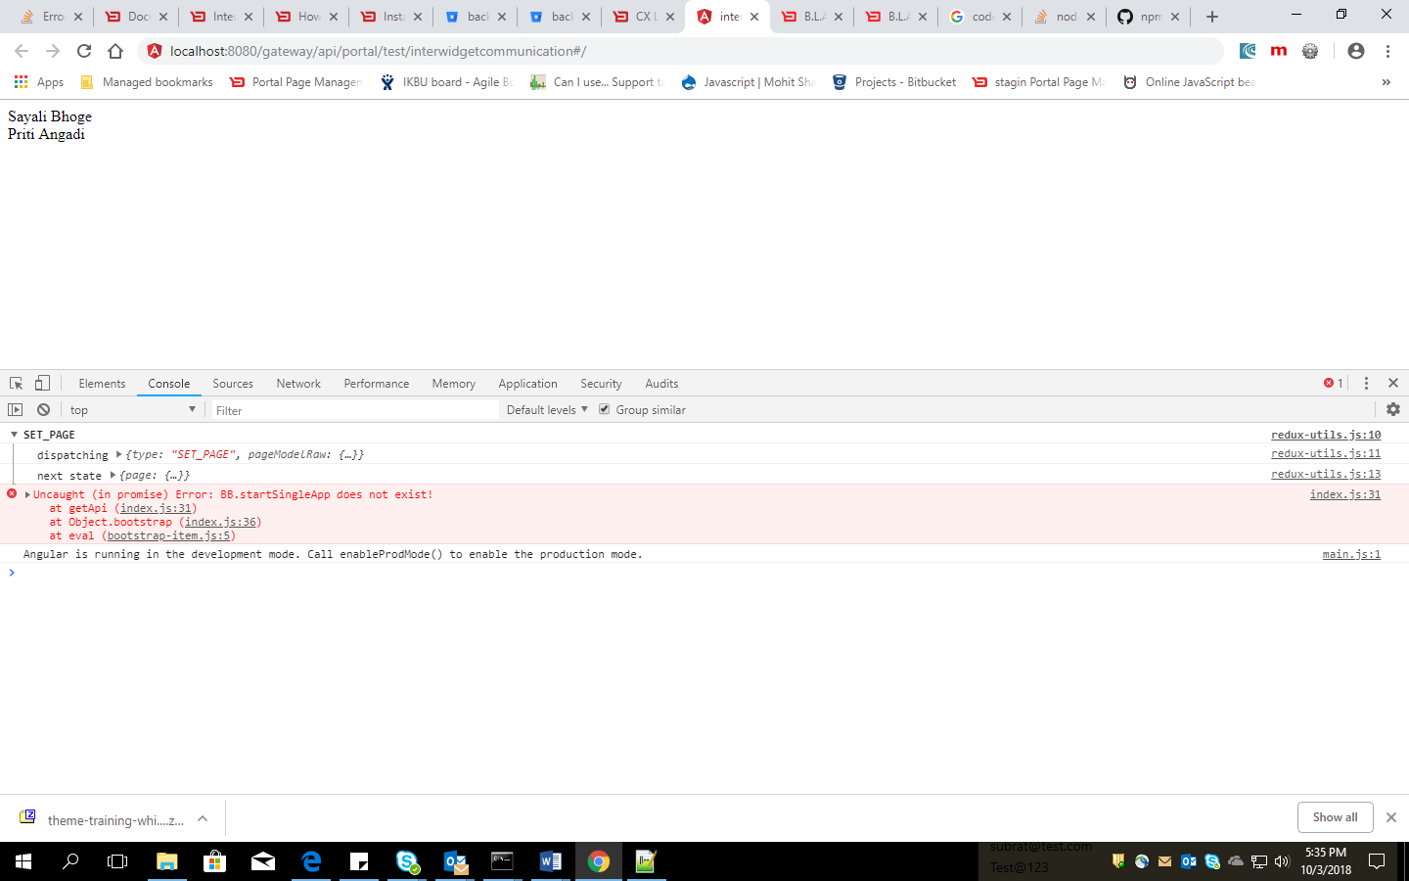

* We can check lean page version in POM.xml of collection websdk . It should be 1.0.3.

